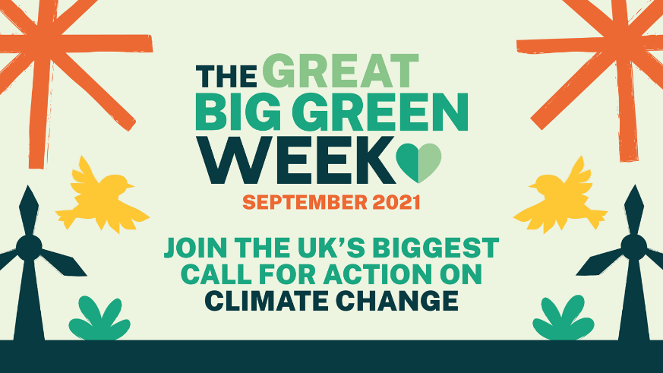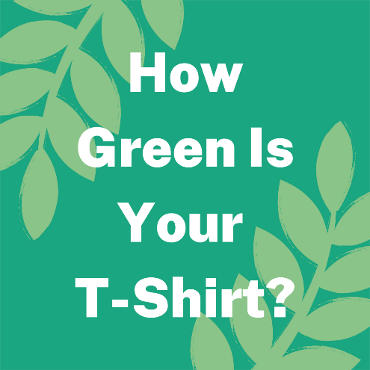

Great Big Green Week 18-26 September 2021
How Green Is Your T-shirt?
The problem
The fashion industry accounts for 8% of all climate emissions, more than the entire economies of the UK, France and Germany combined.
Climate change and fair trade are inextricably linked. The effects of climate change are being felt now in the low income countries where fair trade organisations, farmers, workers and artisans operate.
The background
In October 2019 Fairtrade Yorkshire took part in the Fairtrade Foundation’s Make Your Mark challenge, creating the Fairtrade mark in the form of a human mosaic featuring almost 200 volunteers in Hull’s Trinity Square.
The image is great and enduring. It is used regularly in Fairtrade Foundation communications. The aim was a zero waste event. Dozens of crafters were involved in knitting and crocheting hats for the volunteers, which were later donated to a local charity working with homeless ex service people. The sky blue T shirts and hats were part of the uniform of the Absolutely Cultured volunteers (a legacy of the Hull City of Culture in 2017). The black T shirts were official Fairtrade mark T shirts and have been used to great campaigning effect in the months since.
But the 44 green T shirts – Fairtrade cotton, sustainable and ethical but only worn once. For less than half an hour. Not sustainable. A bit of a waste. What to do?
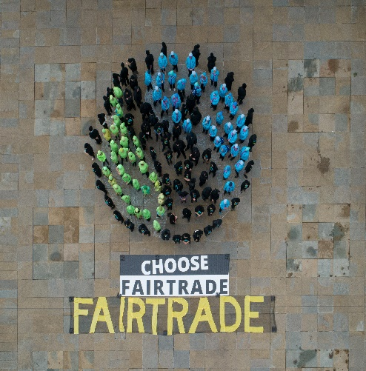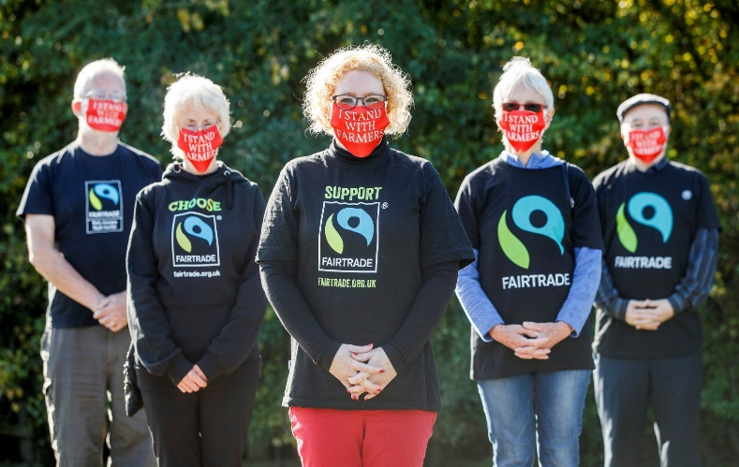

The project
The Great Big Green Week is an initiative from the Climate Coalition – an umbrella group of organisations which campaign on climate, the environment and human rights.
For more details visit: https://greatbiggreenweek.com/
What have we done so far?
We sent green Fairtrade cotton T shirts to around 40 textile artists, crafters, fashion students and artisans to upcycle and create a piece of wearable art with a message about climate change, fair trade and you.
The upcycled garments will be gathered together and styled with fair trade clothing and accessories, second hand and “model’s own” clothing – after all, the most sustainable item is one you already own. We’ll recruit a diverse cohort of models – different body shapes, race, age, disability, gender – and put on a fashion show with a twist during the Great Big Green Week in September.
A select group of invited guests will attend the event which will also be live streamed on the WFTO website and edited into shareable video content, with video diaries and stories from the makers.
The fashion show with a twist is funded via a grant from the Climate Coalition’s Great Big Green Week fund.

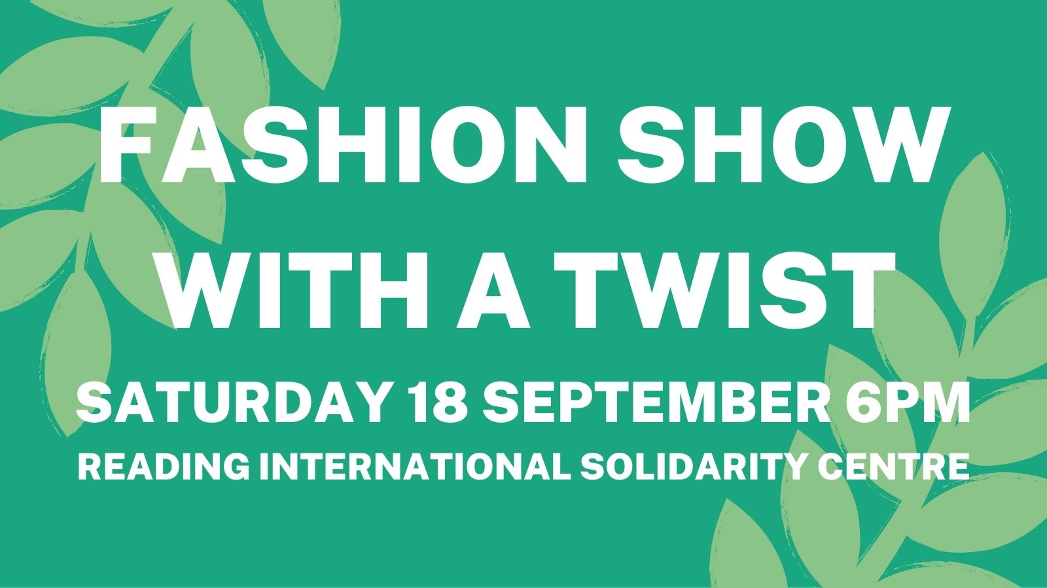

How can you help?
We’re looking for video and still photographers – to help with the livestream the event, and edit the footage down to 30 minutes and 2 minutes.
We need a diverse group of volunteer models for the event.
Are you a fair trade fashion brand willing to donate clothing and accessories for our models to wear alongside the T shirts?
Can you provide images and stories to explain how fair trade fashion can be part of the solution to climate change?
Can you help with connections to ethical, sustainability and fair trade influencers?
Timeline:
Launch – Monday 19 April – Fashion Revolution Week
Summer – Get crafty!
31 August – deadline for return of T shirts to Joanna
Great Big Green Week: 18-26 September
Fashion Show Saturday 18 September 6-7pm at
Reading International Solidarity Centre,
35-39 London Road,
Reading
RG1 4PS
If you would like to get involved please email ChairNCC@fairftrade.org.uk

