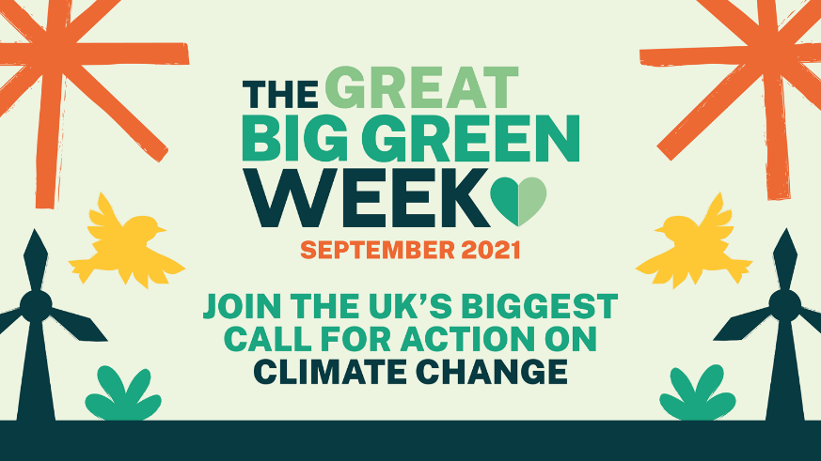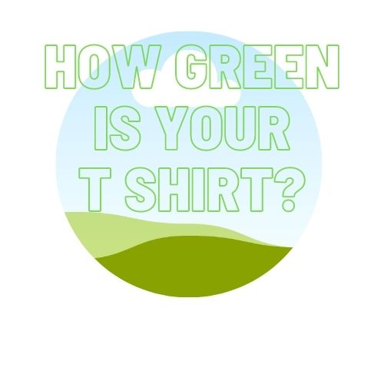

Great Big Green Week 18-26 September 2021
How Green Is Your T-shirt?
The problem
The fashion industry accounts for 8% of all climate emissions, more than the entire economies of the UK, France and Germany combined.
Climate change and fair trade are inextricably linked. The effects of climate change are being felt now in the low income countries where fair trade organisations, farmers, workers and artisans operate.
The background
In October 2019 Fairtrade Yorkshire took part in the Fairtrade Foundation’s Make Your Mark challenge, creating the Fairtrade mark in the form of a human mosaic featuring almost 200 volunteers in Hull’s Trinity Square.
The image is great and enduring. It is used regularly in Fairtrade Foundation communications. The aim was a zero waste event. Dozens of crafters were involved in knitting and crocheting hats for the volunteers, which were later donated to a local charity working with homeless ex service people. The sky blue T shirts and hats were part of the uniform of the Absolutely Cultured volunteers (a legacy of the Hull City of Culture in 2017). The black T shirts were official Fairtrade mark T shirts and have been used to great campaigning effect in the months since.
But the 44 green T shirts – Fairtrade cotton, sustainable and ethical but only worn once. For less than half an hour. Not sustainable. A bit of a waste. What to do?
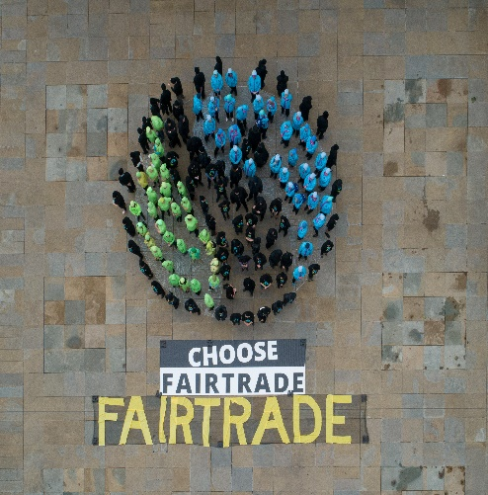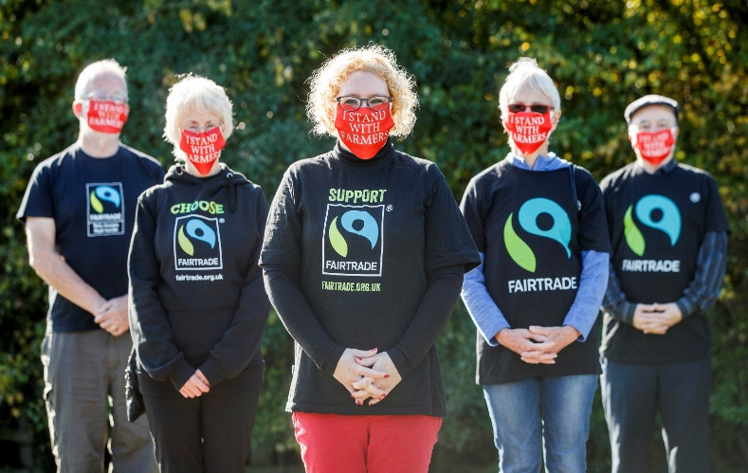
The project
The Great Big Green Week is an initiative from the Climate Coalition – an umbrella group of organisations which campaign on climate, the environment and human rights. The Fairtrade Foundation is a member.
Groups are encouraged to host events across the week in September highlighting the need to tackle the climate emergency.
For more details visit: https://greatbiggreenweek.com/
How can you help?
We’re looking for 40 textile artists, crafters, fashion students and artisans to upcycle the green Fairtrade cotton T shirts and create a piece of wearable art with a message about climate change, fair trade and you. Joanna will post you a T shirt to upcycle and you have all summer to create your piece. Whether you use embroidery, applique, screen printing, block printing, fabric paints or any other textile craft, we want you to get as creative as you like. Each T shirt should become a wearable comment on the climate crisis, fair trade, fast fashion or whatever aspect of the campaign inspires you.
The garments will be gathered together and styled with fair trade clothing and accessories, second hand and “model’s own” clothing – after all, the most sustainable item is one you already own. We’ll recruit a diverse cohort of models – different body shapes, race, age, disability, gender – and put on a fashion show during the Great Big Green Week in September. We welcome 1-2 minute video diaries from the artists as they make the T shirts, and will give you plenty of opportunities to tell your story about why you wanted to take part. People who have made a garment will have the opportunity to model their own shirt.
We would love this to be an in person event, but we have contingency plans for all levels of social distancing measures that might be in place by September. In any case the event will be filmed and made available to view on YouTube, edited to include video diaries and stories from the makers.
Timeline:
Launch – Monday 19 April – Fashion Revolution Week
Summer – Get crafty!
31 August – deadline for return of T shirts to Joanna
Great Big Green Week: 18-26 September
If you would like to get involved please email Joanna.aztecarts@gmail.com

