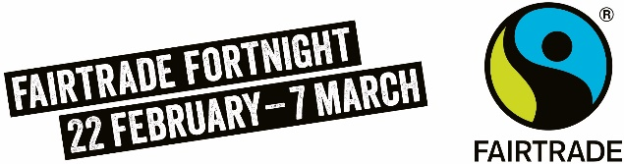
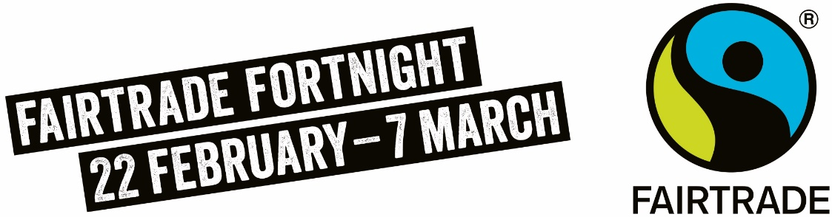
HOW DOES CHOOSING FARTRADE SUPPORT FARMERS FACING THE CLIMATE CRISIS NOW?
The climate crisis is an immediate and ever-increasing threat to the livelihoods of farmers and workers across the world, from deforestation and changing weather patterns to rising temperatures water scarcity and contamination.
Despite contributing the least to the climate crisis, smallholders in developing countries are disproportionately affected and have fewer resources to adapt to changes in climate and other stresses. Farmers have told us that climate change is their biggest challenge right now.
Our global trading system is balanced in favour of the powerful few. The prices that businesses pay for the crops behind some of our favourite foods need to increase significantly if farmers are to escape poverty and still have the means to adapt to economic and environmental shocks.
Fairtrade is about social justice. A root cause of farmers’ inability to adapt and mitigate to climate change is poverty. More money means more climate resilience into the future
Fairtrade works on many levels to strengthen environmental and climate protection for producers and is committed to finding new ways to support producers with the challenges of climate change.
Buying Fairtrade means you are making a wider impact on the planet by supporting a global fight for climate justice. Fairtrade continues to raise the voices of producers and prioritise what they need to respond to the environmental crises unfolding in already vulnerable communities

