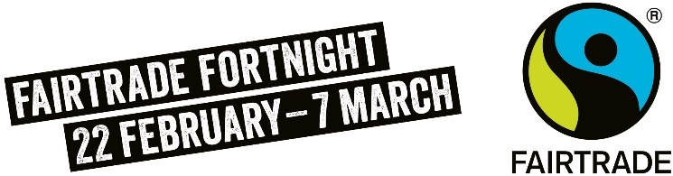
The climate crisis is an immediate threat to the livelihoods of farmers and workers across the world, from deforestation and changing weather patterns to rising temperatures water scarcity and contamination.
Smallholders in low income countries are disproportionately affected and have fewer resources to adapt. Farmers have told us that climate change is their biggest challenge right now.
Fairtrade is about social justice. A root cause of farmers’ inability to adapt and mitigate to climate change is poverty. More money means more climate resilience into the future
Buying Fairtrade means you are making a wider impact on the planet by supporting a global fight for climate justice.
The climate crisis is an immediate threat to the livelihoods of farmers and workers across the world, from deforestation and changing weather patterns to rising temperatures water scarcity and contamination.
Smallholders in low income countries are disproportionately affected and have fewer resources to adapt. Farmers have told us that climate change is their biggest challenge right now.
Fairtrade is about social justice. A root cause of farmers’ inability to adapt and mitigate to climate change is poverty. More money means more climate resilience into the future
Buying Fairtrade means you are making a wider impact on the planet by supporting a global fight for climate justice.
The climate crisis is an immediate threat to the livelihoods of farmers and workers across the world, from deforestation and changing weather patterns to rising temperatures water scarcity and contamination.
Smallholders in low income countries are disproportionately affected and have fewer resources to adapt. Farmers have told us that climate change is their biggest challenge right now.
Fairtrade is about social justice. A root cause of farmers’ inability to adapt and mitigate to climate change is poverty. More money means more climate resilience into the future
Buying Fairtrade means you are making a wider impact on the planet by supporting a global fight for climate justice.
The climate crisis is an immediate threat to the livelihoods of farmers and workers across the world, from deforestation and changing weather patterns to rising temperatures water scarcity and contamination.
Smallholders in low income countries are disproportionately affected and have fewer resources to adapt. Farmers have told us that climate change is their biggest challenge right now.
Fairtrade is about social justice. A root cause of farmers’ inability to adapt and mitigate to climate change is poverty. More money means more climate resilience into the future
Buying Fairtrade means you are making a wider impact on the planet by supporting a global fight for climate justice.

