FOR IMMEDIATE RELEASE
www.fairtrade.org.uk
@FairtradeUKNews

FAIRTRADE CELEBRATES 25 YEARS WITH TOP ETHICAL BRANDS

This October Fairtrade kicks off its 25th birthday celebrations with a long weekend of parties, activities and events from Friday 4th- Monday 7th October 2019, which will see the public show their ongoing support for the 1.6million farmers and workers behind the UK’s most visible ethical label.

Awareness is at an all-time high, 9 out of 10 people know the Mark and it is trusted by 84% of consumers [1]. From modest beginnings in 1994, the Fairtrade Mark is now visible on around 6,000 Fairtrade-certified products on sale for people in the UK.

That’s because of the weight of support from British people for the farmers and workers who produce our favourite things. The public don’t want exploitation to be part of their purchases and by choosing Fairtrade they are giving farmers the hope and reality to help them out of poverty. Today over 1.66 million farmers and workers around the world benefit from sales of Fairtrade products, both directly through fair wages and better working conditions, or indirectly via an additional sum of money that goes directly to the community, the Fairtrade Premium.

Michael Gidney, Chief Executive of the Fairtrade Foundation, said:

“Twenty-five years ago most brands paid little attention to the human cost of their business and most people were unaware of the poverty and degradation that was the reality of life for millions of farmers and workers around the world. Fairtrade set out to change that and put people and the planet before profit. Many said it couldn’t be done, but the public took Fairtrade to their hearts and into their shopping baskets from Day One. Together we led a revolution in the way food is traded. Millions around the world now benefit from fairer trading terms and better working conditions than would ever have been possible before.”

It’s no surprise that as the appetite for ethical food, drink and things to wear grows, so does the variety of Fairtrade products on offer. Here we round up some of the best from the beginning and some of the newest Fairtrade things you can find, and give you a selection of fantastic Fairtrade products to help you have a fun filled Fairtrade celebration.

TOP 4 FOR FAIRNESS

Clipper, Percol, Cafédirect and Green & Blacks were the first to carry the Fairtrade Mark on products in the UK. These brands have come a long way and here we round up the best of the classics.

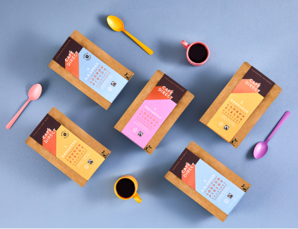
Cafédirect
London Fields range (new for 2019)
RRP: £5.50
Where to buy: Waitrose

Cafêdirect sources 100% Fairtrade coffee, tea and hot chocolate from 13 countries and works directly with 18 coffee growing co-operatives. They launch a special London Fields batch roasted blend of coffee this year, fresh from their own roastery. Specially selected by the Cafédirect certified Q Grader you’ll find a fragrant single origin coffees from Le Paz (Hondouras), South Kivu (D.R. Congo) and Aceh (Indonesia) that suits every taste.

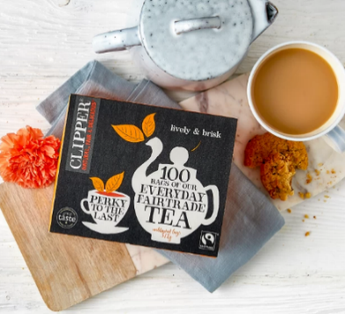
Clipper teas
Classic Black Everyday Fairtrade (80 bags)
RRP: £3.49
Where to buy: Clipper Online, plus all major retailers

Clipper Tea was the UK’s first and today is the world’s largest Fairtrade tea brand. They was the first brand to offer green tea to consumers in UK supermarkets and in 2018 Clipper introduced the world’s first plastic-free, non-GM & unbleached heat-sealed tea bag made from all plant-based materials. Their classic everyday Fairtrade tea is harvested from rich red soils in Africa and is fresh and punchy in perfect measures.

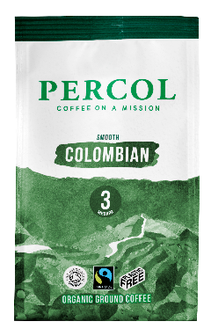
Percol Coffee
Smooth Columbian single origin ground coffee
RRP: £2.62
Where to buy: Sainsbury’s, Waitrose, Tesco, Co-op, Asda, Morrisons, Foody Licious, Amazon

Since its launch in 1987, Percol Coffee has always been dedicated to supporting the farmers who grow its award-winning coffee beans. In 2018 they leapt into plastic free as the first brand to receive the ‘Plastic Free Trust Mark’ from A Plastic Planet. Look out for this balanced blend, which has hints of delicious berry.

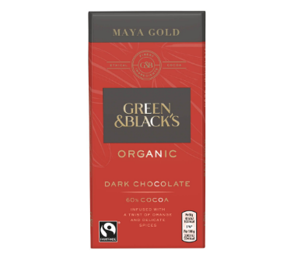
Green & Blacks
Maya Gold
RRP: £2.00
Where to buy: Green & Blacks online, Sainsbury’s, Waitrose, Tesco, Co-op, Asda, Morrisons, Amazon
Green and Black’s launched the first ever chocolate bar with the FAIRTRADE Mark on it, with Maya Gold. It’s made with deliciously dark Fairtrade cocoa and spices from Belize. Today Green & Black’s Classic range is Fairtrade certified and is made with organic cocoa beans from the Dominican Republic.

FAIR AND FUNKY: YOU MIGHT NOT KNOW

Fairtrade is cool! From the handful of businesses aligning their values with the movement at the start, there have been numerous companies looking for the stamp of approval, and now there are over 600 using the Fairtrade Mark. It’s not just food, Fairtrade works with cotton farmers, gold miners and the most imaginative producers, from Ben & Jerry’s to your local coffee shop, from Starbucks to Orkney chutney. Here’s a few of our favourite funky choices taking Fairtrade right on into the next 25 years.

CRED Jewellery
Fairtrade Gold
RRP: various, bespoke pieces
Where to buy: Cred Online
Founded in 1996 to improve the lives of small-scale gold miners, CRED are pioneering in the ethical jewellery arena. They have a range of stunning pieces made from Fairtrade Certified Gold, which was launched in 2011 as the first fully traceable jewellery to hold the Fairtrade Gold Mark. From bespoke engagement rings to gorgeous gifts, you can now find a beautiful piece of ethical, Fairtrade Gold jewellery for your special occasion.

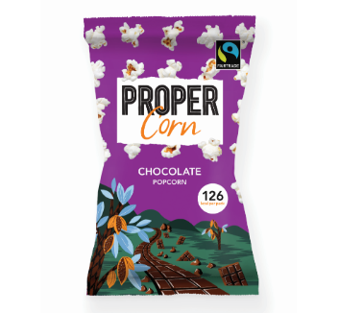
Propercorn
Chocolate Popcorn
RRP: £1.60 per 100g
Where to buy: Tesco, Waitrose, Amazon, Ocado
Did you know you can get Fairtrade popcorn?! And chocolate popcorn to boot! Propercorn launched their foray into Fairtrade in 2017 with delicious Perfectly sweet popcorn and now you can get tempting chocolate popcorn, made with Fairtrade certified cocoa and sugar. Great for any party celebration!

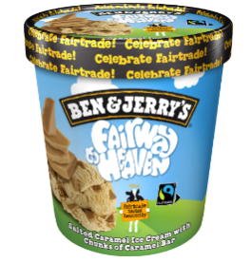
Ben & Jerry’s ice cream
‘Fairway to Heaven’
RRP: £5.00
Where to buy: exclusively at the co-op
A new launch to celebrate 25 years of Fairtrade and show how committed Ben & Jerry’s are about their Fairtrade credentials, I bet you hadn’t even realised something do tasty could be Fairtrade too! Yes, thank goodness, all of Ben & Jerry’s magical flavours are all Fairtrade!

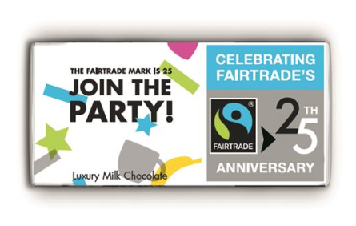
The Meaningful Chocolate Company
Fairtrade 25th anniversary bar
RRP: The bars are sold in cases of 12 and cost £36 (£3 each)
Where to buy: www.fairtrade25th.uk
Help celebrate 25 years of the Fairtrade mark in the UK with the new Fairtrade 25th anniversary milk chocolate bar. Produced by the The Meaningful Chocolate Company, the 80g bar carries the Fairtrade Foundation's 25th celebration logo and fun colourful confetti – perfect for any anniversary celebration! Plus any Fairtrade organisations can claim a £10 discount off the full case price by using the code FT25.

RAISE A GLASS WITH FAIRTRADE

Looking for something Fairtrade for your celebration? There’s a variety of alcoholic and non-alcoholic drinks to add a bit of sparkle to any party.
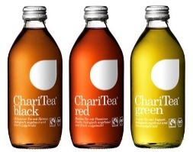
Charitea+
Classy glass bottles and all-natural fizzy and still drinks. Charitea+ offer tea based refreshing drinks as well as more traditional fizzy ones like LimeAid. Try them on their own or mix with Fairtrade spirits to create something special for your celebration.
https://charitea.com/en/
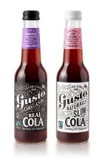
Gusto Organic Drinks
Try Gusto’s new flavours for a twist on a classic. Their natural cola is made from real cola nuts and sourced from Fairtrade and organic ingredients. Or go wild with a hint of guarana, ginseng and Chinese herbs in their natural energy drink. Gusto have been around since 1990 too, so joined us early on the Fairtrade journey. https://drinkgusto.com/

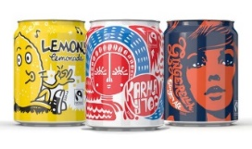
Karma Cola
Fairtrade’s very own rebel-cola and fab and funky ginger drinks. Gingerella is a firey gingery favourite and the cool mini cans make a real impact for any party.
https://karmacola.co.uk/

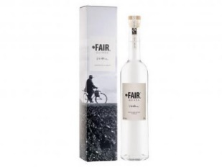
FAIR Drinks
Did you know about Fairtrade Vodka? Love an espresso martini? You’ve come to the right place! FAIR Drinks believe in treating all people fairly and their search for high quality fair ingredients has taken them around the world. The Fairtrade quinoa vodka is a top seller, and the classic Fairtrade coffee liquer is close behind (and a perfect pairing for a cocktail!)
https://www.fair-drinks.com/

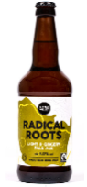
Radical Roots Pale Ale
Created by Devon based Little Valley brewery, combining fresh ginger, dried fruit and citrus, this pale ale builds to a deliciously light and spicy finish. Get your case of 12 bottles to get the party started!
https://littlevalleybrewery.co.uk/shop/radical-roots/

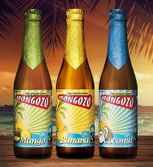
Mongozo Beer
The world’s first organic, gluten-free and Fairtrade lager. Mongozo have a classic pilsner or buckwheat white beer, they are World Beer Awards winners and now there’s three fruity flavours to try, for an even wilder party!
https://www.mongozo.com/

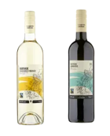
Co-op Fairtrade Wines
Looking for a Fairtrade wine to impress your guests? The Co-op stock a large range of red, white and rose wine that’s all Fairtrade! Wines come from Fairtrade vineyards in South Africa, Argentina and Chile where workers and their families benefit from Fairtrade Premium projects.
https://www.coop.co.uk/products/fairtrade-wine

CELEBRATE FAIRTRADE CAKE

No party is complete without a celebration cake. We’ve got some fantastic recipes for you to try, but first, make sure your baking cupboard is well stocked with Fairtrade ingredients.
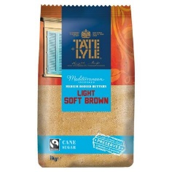
Tate & Lyle Fairtrade sugar
Where to buy: Co-op, Waitrose, Tesco, and many other retailers
We can’t deny we all love a bit of sugar. Tate & Lyle have a great variety, from pure white caster sugar to dark muscavado. Many retailers also stock their own-brand Fairtrade sugar, so just look for the FAIRTRADE Mark when you’re next on the hunt to baking ingredients.

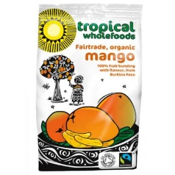
Tropical Wholefoods dried fruit
Where to buy: Tropical Wholefoods online, Oxfam shops, Holland and Barrett, Planet Organic
Add a bit of a zing to your celebratory sweet treats! Tropical Wholefoods have a huge range of dried fruits, from mango to sultanas, cashew nuts to dates. Or even a bit of dried banana for and extra special banana bread!

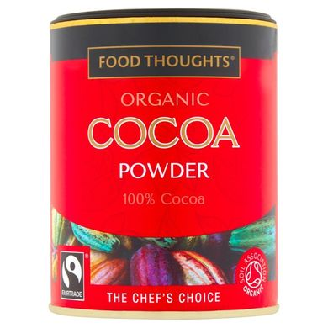
Sainsbury’s Food Thoughts Fairtrade Cocoa powder
Where to buy: Sainsbury’s stores
Don’t forget a deliciously dark chocolate cake for your celebration. This cocoa powder is made from entirely organic Fairtrade cocoa bans for an intense quality of flavour.

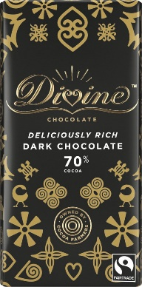
Divine’s 70% Dark Chocolate
Where to buy: Divine online, Waitrose, WH Smith’s, The Co-op, Riverford Farm Shop, Oxfam stores
If you didn’t have enough chocolate for your celebration, this deliciously dark chocolate from Divine is from their Fairtrade farm in Ghana, Kuapa Kokoo who own the largest share of the company. If you can hold off eating it all it’s great in this chocolate and raspberry truffle cake.

CRUISING INTO 2020

Fairtrade doesn’t stand still for long and we’re excited to be joined by new businesses and new launches in Fairtrade’s 25th year… there’s lots of excitement just around the corner so keep your eyes peeled for the FAIRTRADE Mark!

– ENDS –
Notes to Editors
In 1992 the Fairtrade Foundation was established by a group of charities including Oxfam, Traidcraft, two years later the following brands launched the first Fairtrade products in the UK in 1994:

Cafédirect
- Cafêdirect sources 100% Fairtrade coffee, tea and hot chocolate from 13 countries and works directly with 18 coffee growing co-operatives.
- Cafêdirect was founded by 4 UK charities in 1991 and today gives 50% of its profits directly to a farmer-led charity, Producers Direct, which supports over 600,000 farmers in improving the quality of their crops and their livelihoods.
- Cafédirect became the first UK coffee company to be B Corp certified in 2018.

Clipper Tea
- Clipper Tea was the UK’s first and today is the world’s largest Fairtrade tea brand.
- Clipper’s Fairtrade premium contributions actively support 114,000 tea producers and their families annually by investing in education, healthcare and topping up workers’ pension pots
- Clipper was the first brand to offer green tea to consumers in UK supermarkets and in 2018 Clipper introduced the world’s first plastic-free, non-GM & unbleached heat-sealed tea bag made from all plant-based materials

Percol Coffee’s Fairtrade Story
- Since its launch in 1987, Percol Coffee has always been dedicated to supporting the farmers who grow its award-winning coffee beans.
- Percol’s new campaign - “Coffee on a Mission” - is to be the most ethical and sustainable coffee company. Plastic-free. Carbon-neutral. Fairtrade-certified: http://www.percol.co.uk/coffee-on-a-mission/
- Percol was the first coffee brand to receive the ‘Plastic Free Trust Mark’ from A Plastic Planet, which now appears on their home compostable Ground, Beans and Coffee packaging

Green and Black’s
- Green and Black’s became the first to launch a chocolate bar with the FAIRTRADE Mark on it with Maya Gold made with cocoa and spices from Belize
- Today Green & Black’s Classic range is Fairtrade certified and is made with organic cocoa beans from the Dominican Republic.

The Fairtrade Foundation has footage, photography, case studies and stories about the people benefitting from Fairtrade, including some of the communities who have benefitted from 25 years of Fairtrade, and can arrange interviews with spokespeople including Fairtrade staff, campaigners, farmer representatives. Our Media team can also put journalists in touch with the 25th brands.

Fairtrade International Climate Change film: https://vimeo.com/241712627

For more information, images and spokespeople please contact:

Justin Avern  Head of Media Relations  020 7440 7686/ 07770 957 451  justin.avern@fairtrade.org.uk | Martine Parry  Media and PR Manager  020 7440 7695  martine.parry@fairtrade.org.uk | Susannah Henty  Media and PR Manager  020 7440 8597  susannah.henty@farirtrade.org.uk | Emily McCoy  Media Officer  020 7440 7692  emily.mccoy@fairtrade.org.uk

About Fairtrade
The international Fairtrade system exists to end poverty through trade. The Fairtrade Foundation is an independent certification body and NGO which licenses the use of the FAIRTRADE Mark on more than 6,000 products which meet its rigorous social, economic and environmental standards. This independent label signifies to consumers that farmers and workers across 73 developing countries are getting a better deal from trade.

Today, more than 1.6 million people who work hard to produce coffee, tea, cocoa, bananas, wines, flowers, cotton, gold and many other products benefit from Fairtrade, which campaigns for as well as enables a fairer system of global trade.

Beyond certification, the Fairtrade Foundation is deepening its impact by delivering specialist programmes to help disadvantaged communities boost productivity in the face of challenges such as climate change.

Fairtrade Foundation
5.7 The Loom | Gowers Walk | London | E1 8PY

Tel: +44 (0)20 7405 5942 │ Fax: +44 (0)20 7977 0101 │www.fairtrade.org.uk
Company Registered in England and Wales number 2733136. Registered Charity number 1043886. VAT number 672 5453 23

